Article ID: 7213
Article Name: My vacuum cleaner has oval tubes, how can I fit standard round accessories
Topic Location: Floorcare, bag/bagless/central cleaners,usage, performance
Meta-data:
Related Articles:
Related Questions:
PNC
DIY
Safety
Link
Email
Book Engineer
Multimedia
Brand
Article Content:
If you have an oval tube on your vacuum cleaner there is a adapter that you can use to be able to attach round nozzles or accessories. This can be bought in our webshop, use the link below.
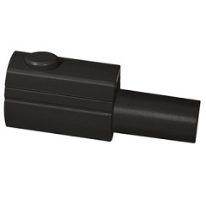
[lik to webshop]

